**EVNIRONMENTAL SETUP**

|  |  |
| --- | --- |
| **Date** | **Nov 2022** |
| **Team ID** | **PNT2022TMID37600** |
| **Project Name** | **CUSTOMER CARE REGISTRY** |

**FLASK SETUP:**

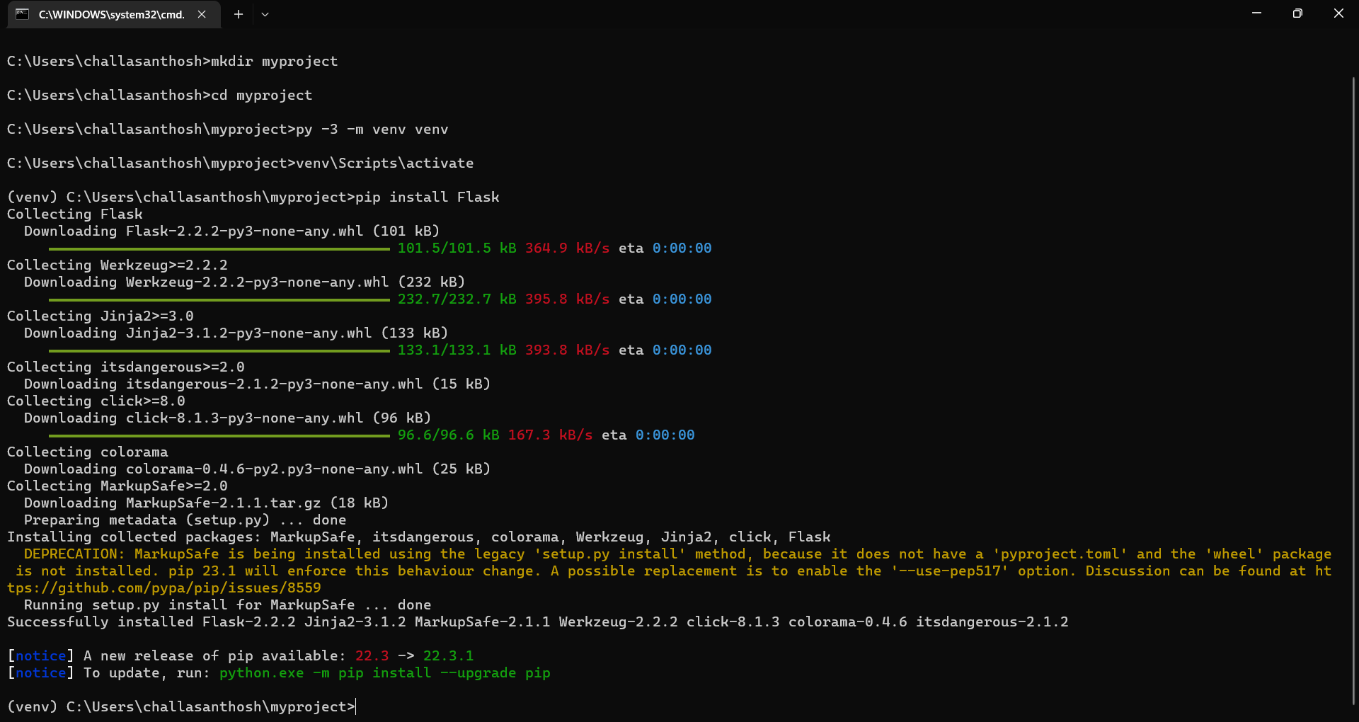

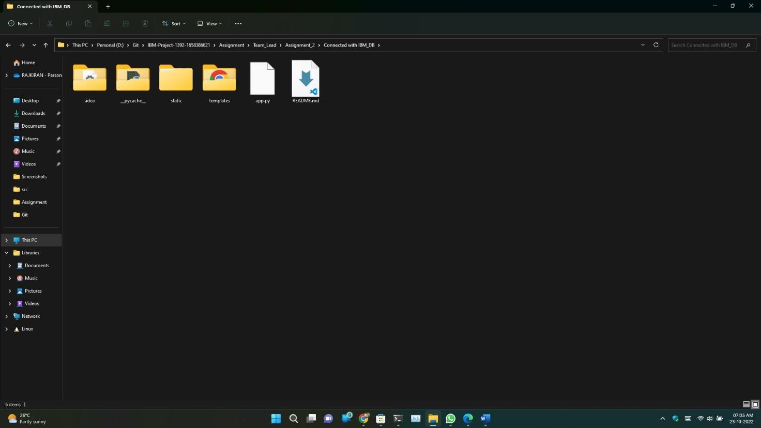

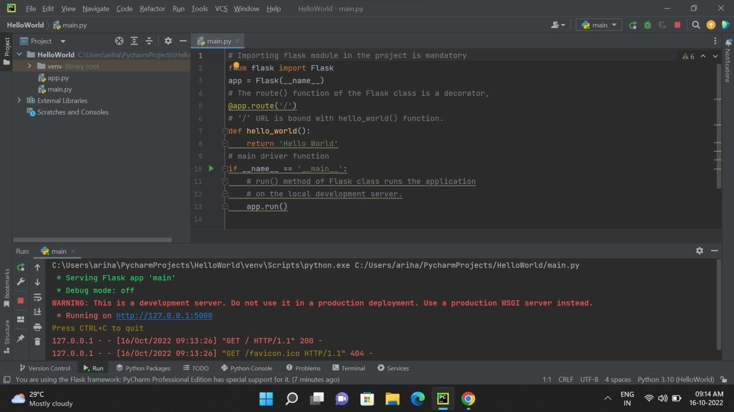

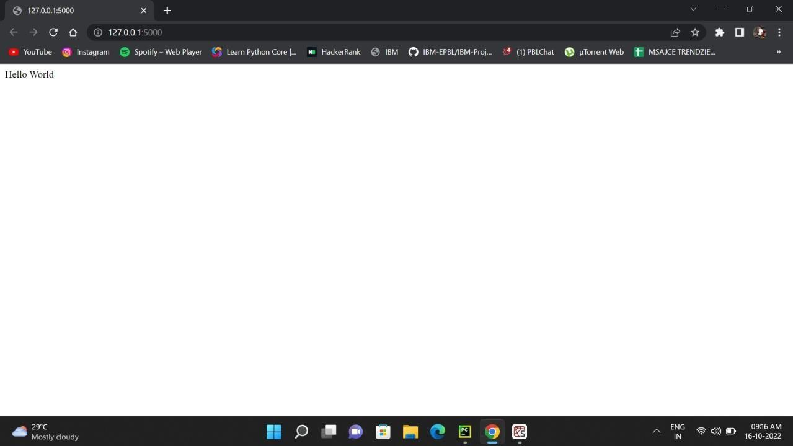

**ClOUD ACCOUNT CREATION:**

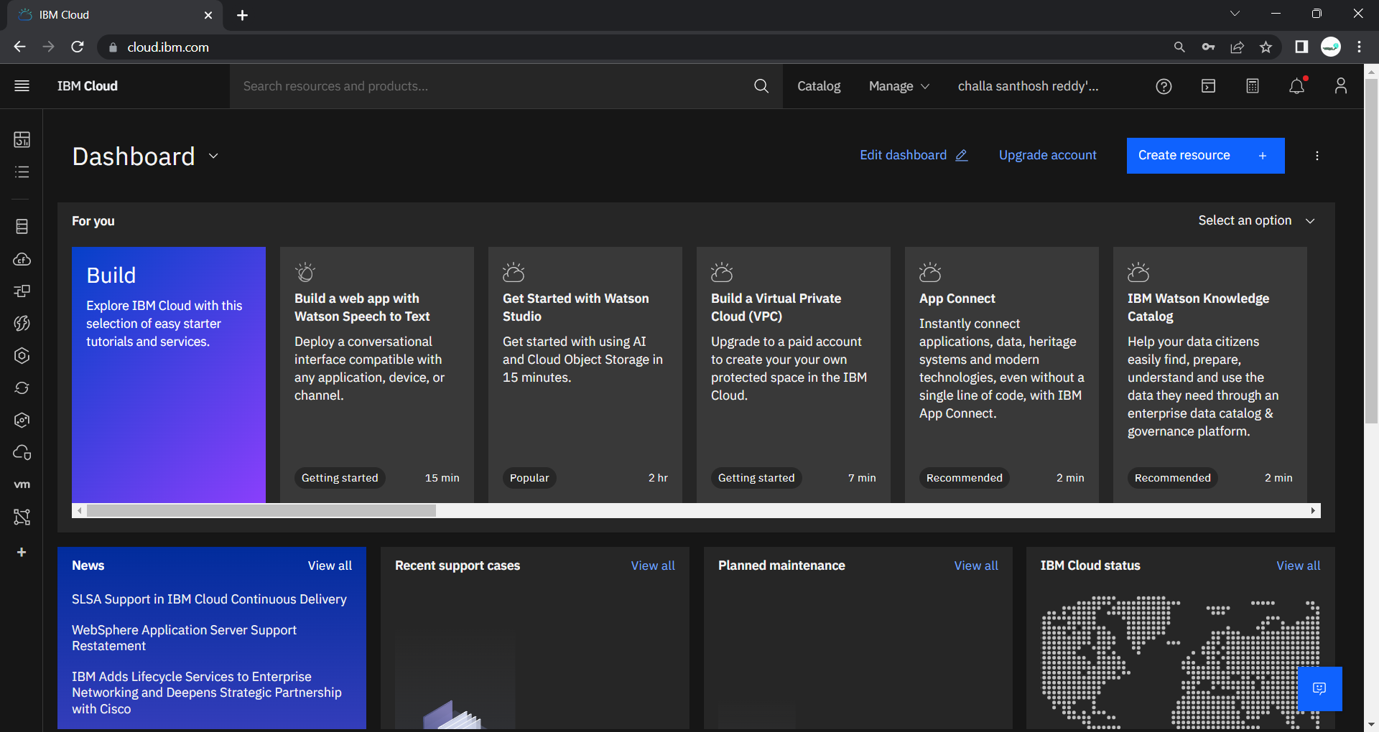

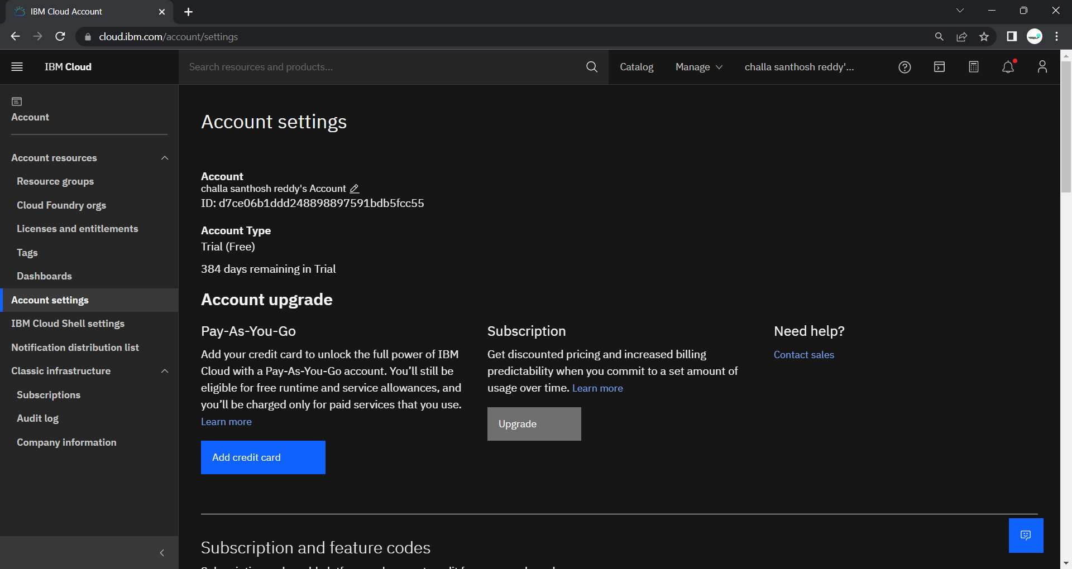

**IBM CLOUD CLI INSTALL :**

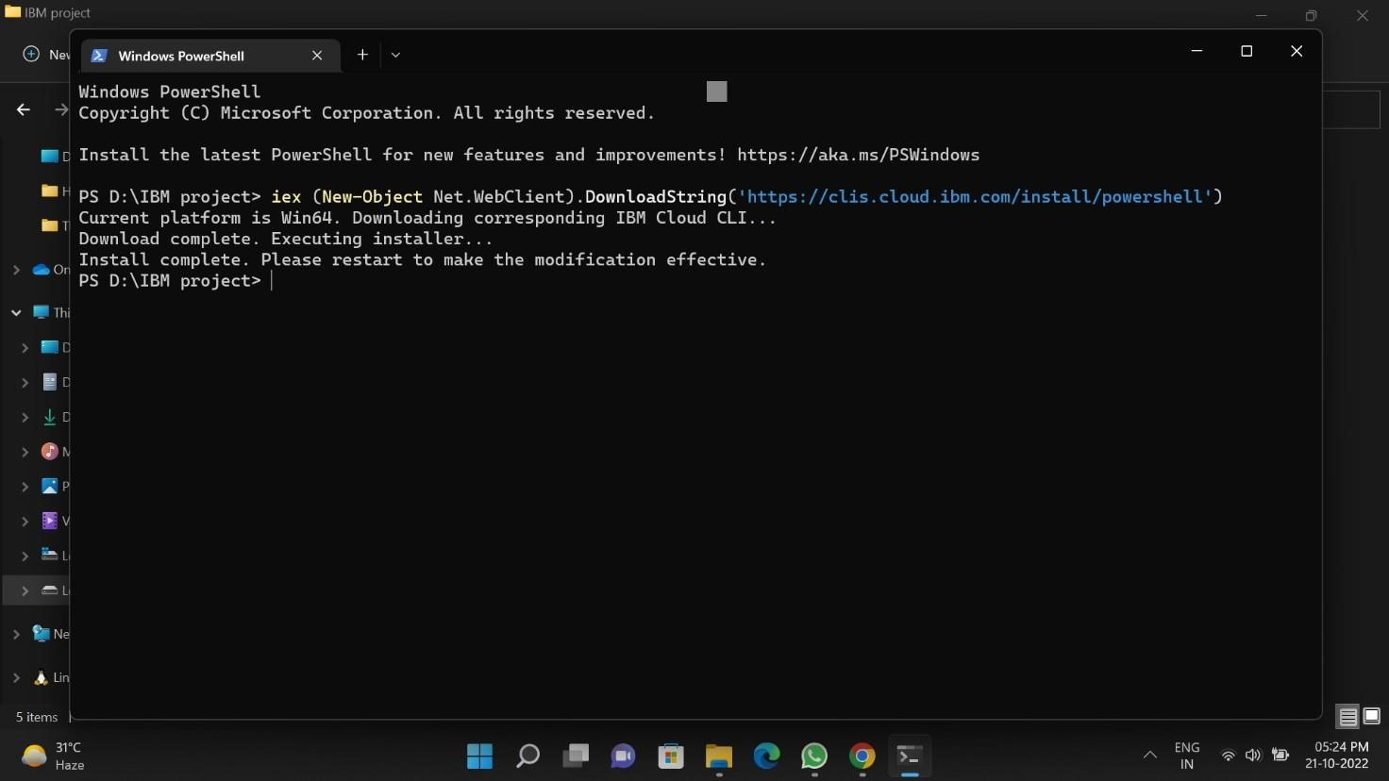

**DOCKER SETUP:**

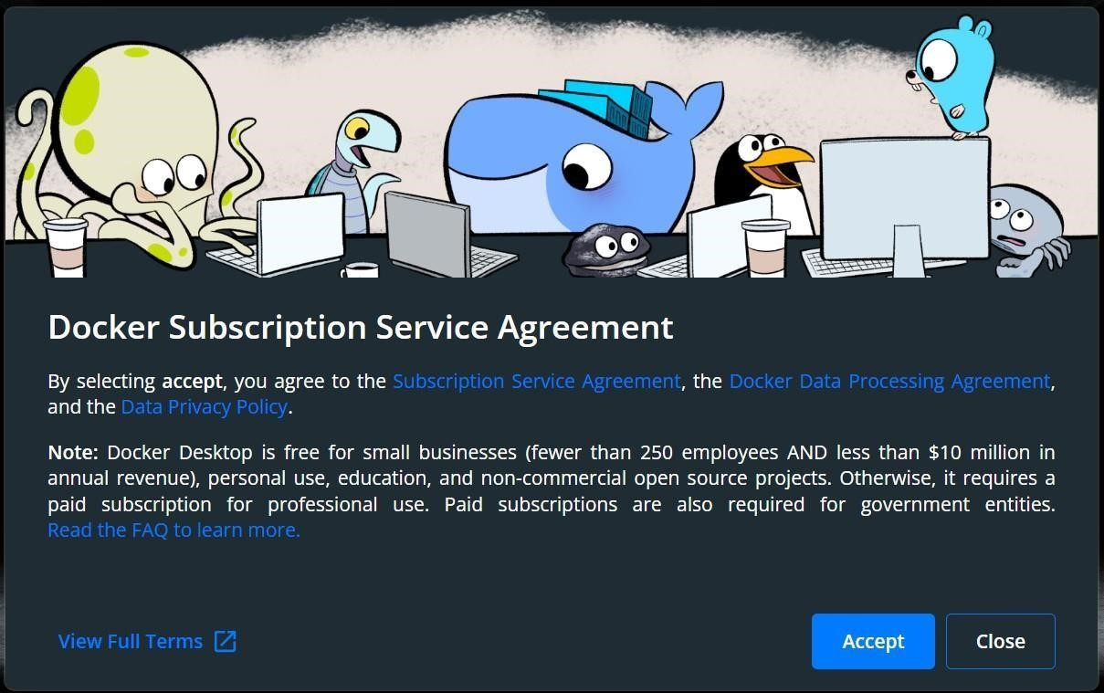

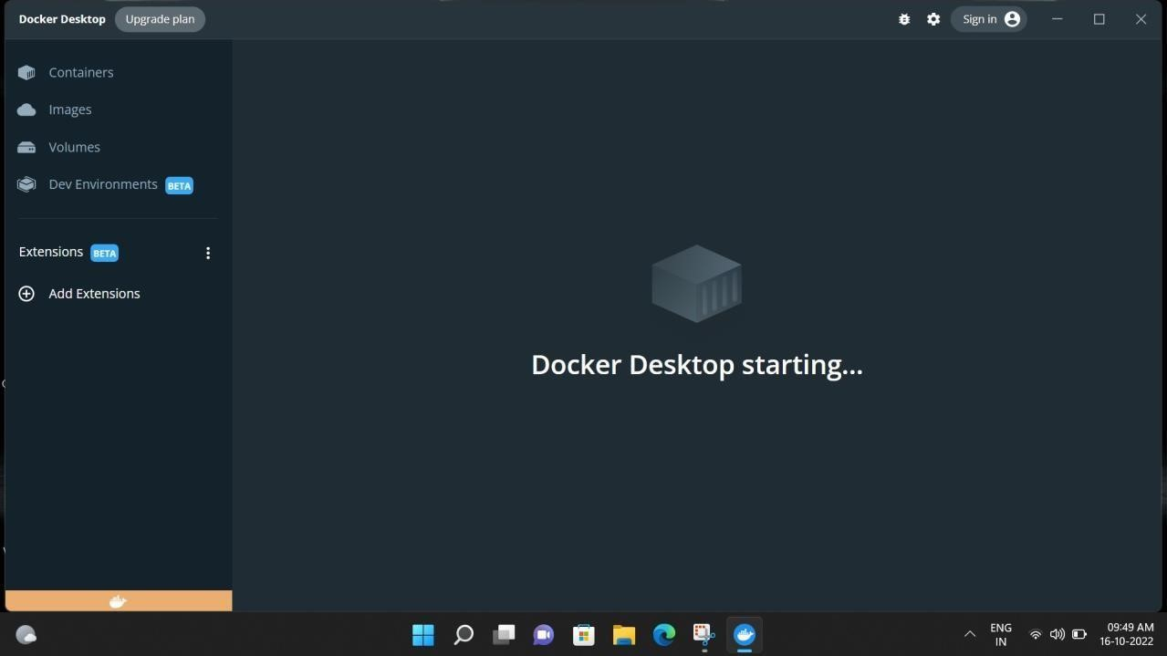

**SENDGRID ACCOUNT CREATION:**

